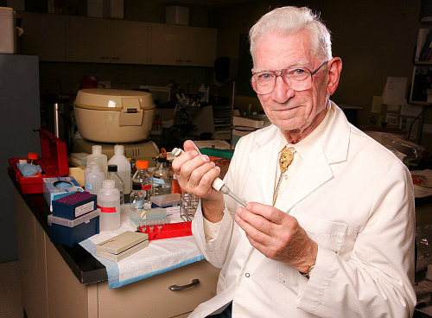

University of Minnesota Duluth pathologist Arthur Aufderheide is shown here in the DNA lab at the School of Medicine at UMD in this May 27, 2005, file photo. Aufderheide died Friday, Aug. 9, 2013, at age 90. (2005 file / News Tribune)

Duluth 'Mummy Doctor' Aufderheide dies
Arthur Aufderheide, a longtime pathologist at the University of Minnesota Medical School in Duluth, died Friday at age 90.
By: Jana Hollingsworth and Mike Creger, Duluth News Tribune
Pathologist, explorer and “Mummy Doctor” Arthur Aufderheide died Friday in Duluth. He was 90.
The colorful character who moved to Duluth in 1953 to work at St. Mary’s Hospital eventually entered a field of work he helped found, paleopathology, or the study of disease patterns in mummies. The work put him in all corners of the world with his wife, Mary, at his side and gained him international acclaim.
“My contribution to the field in general was to make other people aware that … there is medical and anthropological information in mummies,” Aufderheide told the News Tribune in 2008, the year he officially retired from the University of Minnesota Medical School in Duluth. He joined the school in 1972.
Mary Aufderheide said he kept mentoring and sharing his knowledge with others after retirement.
He began building a database of mummies while in his 50s and has the largest collection in the world of mummy remains, with between 5,000 and 6,000 specimens.
Daughter Pat Aufderheide is a professor and director of the Center for Social Media in the School of Communication at American University in Washington, D.C.
She said her father’s work as a scholar and a teacher, along with his dedication to his students, inspired her.
Her father, she said, “encouraged me from the earliest moments to constantly be curious about the world. To constantly be skeptical and have a scientific approach to knowledge and ask questions.”
His encouragement of Pat, now 64, to use her influence, go to college and build a career was forward-thinking for the time, she said.
“Of course, he was a terrific dad,” she said. “One of the wonderful things about him, when he was in town he wanted to take us to the shore and explore nature and go on hikes: the Baptism River and Gooseberry Falls, cross-country skiing and snowshoeing. He taught us to love the outdoors and not be afraid of weather.”
Aufderheide was especially fond of the Arctic, helping to inspire the Ralph Plaisted snowmobile expeditions to the North Pole in the late 1960s and collaborating with photographer Jim Brandenburg with a film archive of Arctic culture. He spent three winters living with Inuits as part of his studies.
Aufderheide was featured in an in-depth article in the May 16, 2005, issue of the New Yorker. It’s where the term “Mummy Doctor” came into play. He told the magazine his body wouldn’t be around for future study because he planned on being cremated.
Aufderheide also said he was happy to take on his new role teaching pathology at the medical school despite being in his 50s and not having a Ph.D. He attended medical school during World War II and was key in bringing pathology studies to the then-fledgling medical school. He decided to plunge forward in his own style.
“I couldn’t see spending seven or eight years getting a Ph.D. in some basic science,” he told the magazine. “So I decided to go with what I’ve got. I’m a physician. I enjoy travel and unfamiliar cultures. Why not study the diseases of ancient people.”
There will be a memorial service at 2 p.m. Aug. 24 at the Kirby Student Center Plaza Ballroom at the University of Minnesota Duluth.
Aufderheide is survived by his wife, Mary, and children Patricia, Walter and Tom.
He spoke to the News Tribune about his family shortly after the article appeared in the New Yorker.
“Mary is warm and open, but particularly she’s good at foreign languages,” Aufderheide said. Those traits came in handy in foreign lands when the couple sought permission to sample tissue from mummies. “She opens the doors. I couldn’t make it happen.”
Much like his own children, Aufderheide said he was fueled by the spirit of his students.
“Being around young people is such a stimulus,” he said. “They’re so excited about life.”
Mary said Wednesday that he always was willing to mentor them.
“If they had a problem, he would help fix it,” she said. “He wanted to help. He loved solving problems.
He spent the last week of his life in Duluth’s Solvay Hospice House, Pat said, and welcomed a “parade of visitors.”
“The number of people who said to me ‘he was my second father,’ I can’t even begin to count,” Pat said. “You could hear a lot of laughter and tears in that room. … You could see right there one example of the way he touched people’s lives. He had an amazing life, and it was a really fulfilling life.”
Art and Mary met during World War II. She was working in a psychological ward at a hospital and Aufderheide was called in as a student to help with a patient.
“He was such a nice person,” she recalled.
Aufderheide eventually asked her if she would like to “go out for a Coke tonight.”
Mary said no.
“I thought ‘that was a foolish thing to do. There goes my chance,’ ” she said.
But Aufderheide came back the next day and asked again. She was sure to say “yes” that time.
“We always said we met in a psych ward and we were crazy ever since,” she said.
“We had 67½ years of just wonderful happiness,” she said. “The house seems so empty without him.”

